Practical File
of

Back End Engineering-II (23CS008)

Semester-V (Batch-2023)



Supervised By: Submitted By:
Dr. Gagandeep Kaur N Gaurav Singh Heer, 2310991574(G-17)
Faculty Name

Department of Computer Science and Engineering Chitkara
University Institute of Engineering & Technology,
Chitkara University, Punjab

TABLE OF CONTENT

S. No. | Topic | Page No.
1. | Node JS in My own Words | 3
2. | Modules Used in my Project. | 3
3. | Provide Sample input to run your program | 4-6

1. Node.js in My Own Words
Node.js is a powerful JavaScript runtime environment that allows developers to execute JavaScript code outside the browser, typically on the server. It is built on Google Chrome's V8 JavaScript engine, making it fast and efficient.
In simple terms, Node.js allows us to write server-side applications using JavaScript—one language for both frontend and backend development. Its non-blocking I/O and event-driven architecture make it ideal for developing scalable, real-time, and data-intensive applications such as chat systems, task managers, APIs, and more.

2. Modules Used in My Project
My Task Manager project is built using both built-in and external Node.js modules, along with a custom NPM module I developed for logging. Below is a brief explanation of each:
- readline (Built-in)
Used to interact with users through the command line. It creates prompts to take inputs like usernames, passwords, and task details in a user-friendly way.
- fs – File System (Built-in)
Handles all file operations, including reading from and writing to:
- user.txt – stores user credentials (username and password)
- tasks.txt – stores task details (ID and title)
- chalk (External)
A popular Node.js package used to style and colorize the console output. It helps highlight important messages like success, error, or warning logs, improving readability.
- task-manager-gaurav-1574 (Custom NPM Module)
This is my self-developed logging utility located in utils/logger.js. It formats log messages based on their type:
- Info
- Success
- Warning
- Error
All messages are displayed with timestamps and appropriate color codes for better clarity.

3. Sample Input
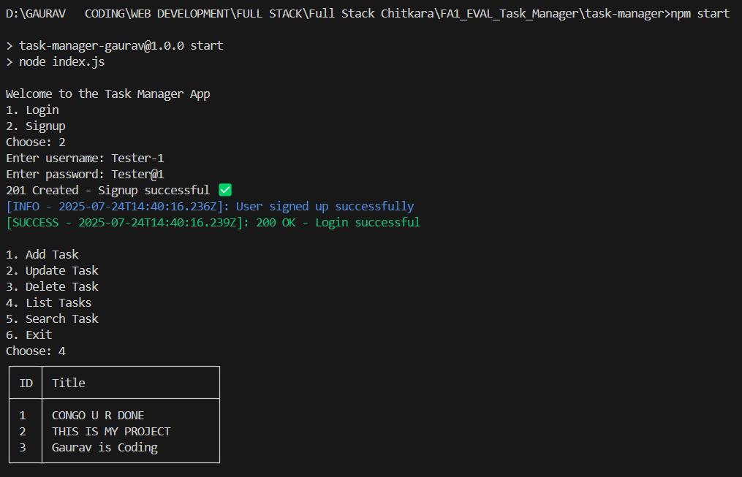
Screenshot 3.1: Sign-Up and List all Tasks

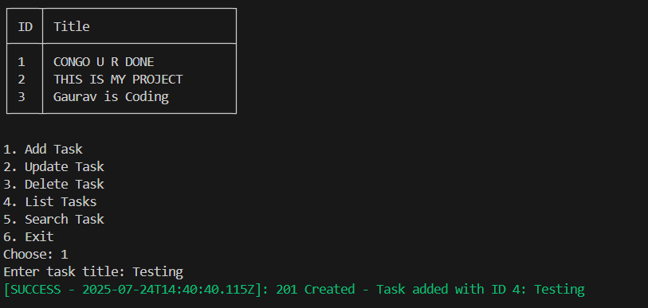
Screenshot 3.2: Add Task

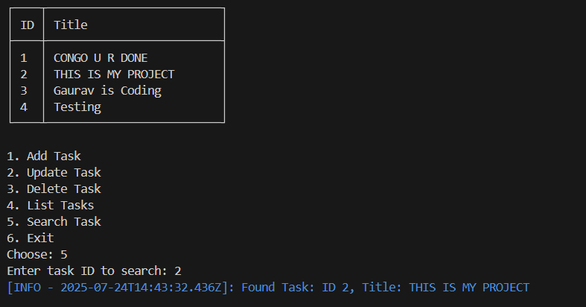
Screenshot 3.3: Search Task By ID

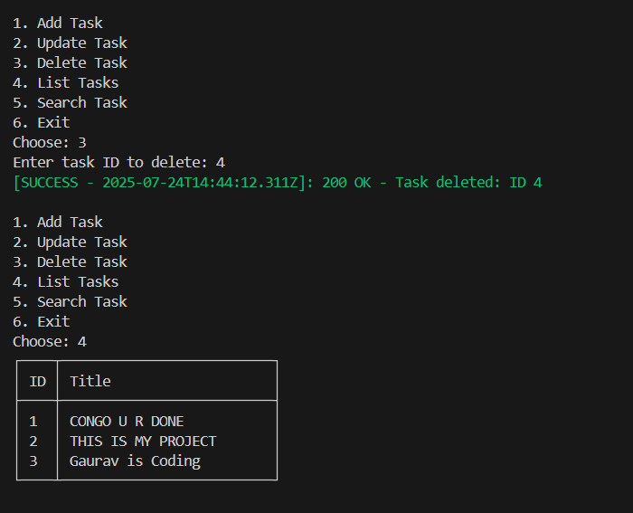
Screenshot 3.4: Delete Task
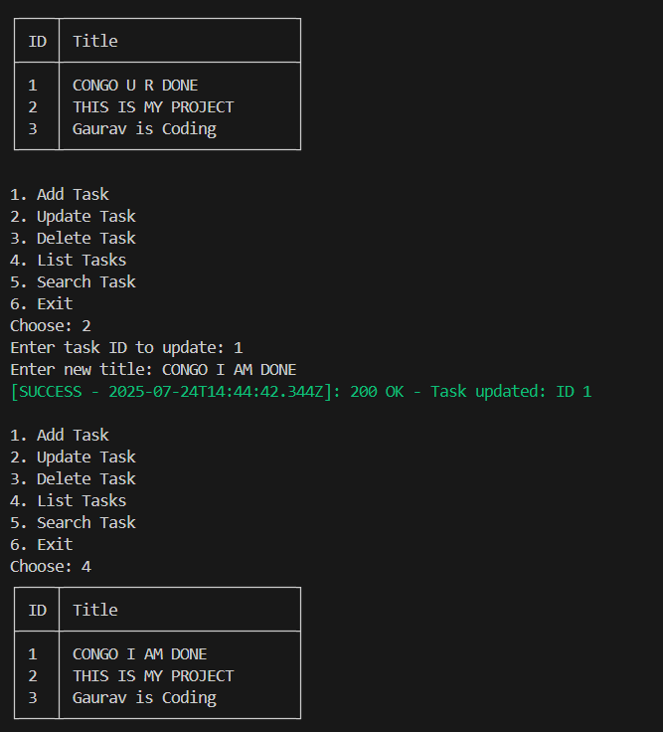
Screenshot 3.5: Update Task

